Revolutionizing Public Restrooms: The Smart Toilet Solution

## Introduction

Welcome to the world of **smart toilets**! In this presentation, we will explore how these cutting-edge facilities are revolutionizing public restrooms. From **advanced sensors** to **automated**

**cleaning**, smart toilets are enhancing hygiene, efﬁciency, and user experience. Join us as we dive into the future of public restroom technology!

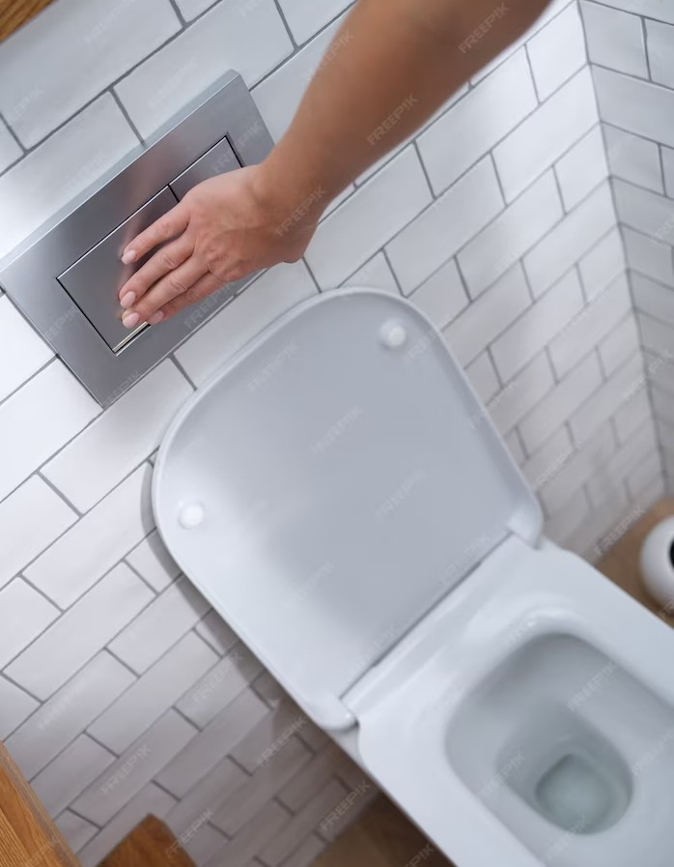

# Improved Hygiene

Say goodbye to unsanitary restrooms! Smart toilets utilize **self-cleaning technology** and **touchless operation** to minimize contact with germs. With **integrated UV sterilization** and **antibacterial surfaces**, these toilets ensure a safer and healthier restroom experience for everyone.

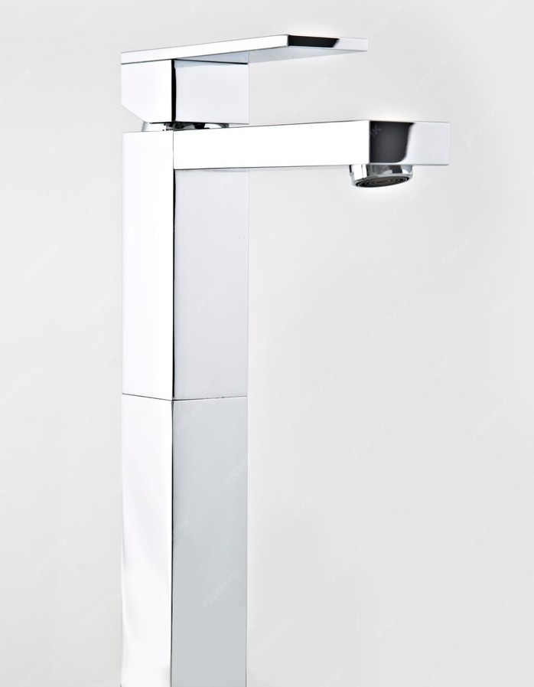

# Enhanced Accessibility

Smart toilets are designed with **universal accessibility** in mind. Featuring **adjustable heights**, **handrail support**, and **braille instructions**, these facilities cater to individuals with diverse needs. By promoting inclusivity, smart toilets are transforming public restrooms into welcoming spaces for everyone.

No more guessing games! Smart toilets employ **real-time occupancy monitoring** to provide users with information on restroom availability. Through **smartphone apps** or **LED indicators**, individuals can easily locate vacant stalls, minimizing waiting times and optimizing restroom usage.



# Water Conservation

Smart toilets are champions of **water conservation**. With **intelligent ﬂush mechanisms** and **water-saving modes**, these toilets reduce water consumption without compromising cleanliness. By embracing sustainable practices, smart toilets contribute to a greener future.

## Enhanced Maintenance

Maintenance made easy! Smart toilets come equipped with **remote monitoring systems** that detect issues such as **clogs** or **malfunctions**. This proactive approach enables prompt maintenance, ensuring that restrooms are always in optimal condition for users.



## Smart Toilet Analytics

Data-driven insights! Smart toilets gather **usage statistics** and **consumption patterns** to provide valuable analytics.



Facility managers can leverage this information to optimize cleaning schedules, monitor supply levels, and enhance restroom operations, resulting in improved efﬁciency and cost- effectiveness.

## Privacy and Security

Restroom privacy is paramount! Smart toilets incorporate **privacy features** such as **soundprooﬁng**, **occupancy indicators**, and **secure locking systems**. These measures ensure a safe and comfortable

experience for users, fostering peace of mind in public restroom settings.

## Future Innovations

The future looks bright for smart toilets! Anticipate exciting advancements like **artiﬁcial intelligence**, **voice-activated controls**, and **personalized settings**. As

technology continues to evolve, smart toilets will redeﬁne the concept of public restrooms, making them smarter, more efﬁcient, and tailored to individual preferences.



## Conclusion

In conclusion, smart toilets are revolutionizing public restrooms by prioritizing hygiene, accessibility, efﬁciency, and sustainability. With their advanced features and data-driven insights, these high-tech facilities are transforming the way we experience and manage public restroom spaces. Embrace the smart toilet solution and embrace a future where restroom experiences are smarter, safer, and more comfortable for all.